**University of Michigan – Dearborn**

**CIS 200 – Computer Science II**

**Lab# 4**

**Professor Robert Mann**

Demetrius Johnson

[meech@umich.edu](mailto:meech@umich.edu)

October 12, 2020

**Table Content**

Contents

Question 1 3

Source Code –see Q1_CIS-200-LAB2-DemetriusJohnson.cpp 3

Screenshots 3

Question 2 11

Source Code –see Q2_CIS-200-LAB2-DemetriusJohnson.cpp 11

Screenshots 11

Question 3 15

Command line arguments in C/C++ 15

Source Code –see Q3_CIS-200-LAB2-DemetriusJohnson.cpp 16

Screenshots 16

# Question 1 (PROGRAM 1)

// LAB 4 - CIS 200

Question 1

-------------------------

## Source Code –see question 1 source code

## Screenshots – drew lines instead of multiple screenshots so it’s easier to see and matchup

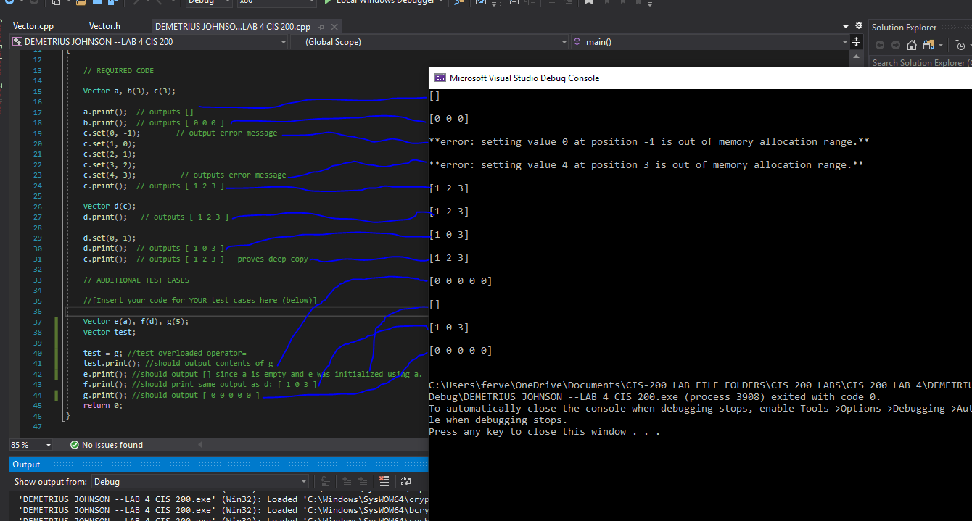

# Question 2 (PROGRAM 2)

// LAB 4 - CIS 200

Question 2

-------------------------

## Source Code –see Q2_CIS-200-LAB2-DemetriusJohnson.cpp

## Screenshots

Test Table:

|  |  |  |  |  |
| --- | --- | --- | --- | --- |
| Test # | Valid / Invalid Data | Description of test | Actual Output | Test Pass / Fail |
| 1 | valid | Print array using standard array subscript notation 'myArray[]': | See screenshot | pass |
| 2 | valid | Print array using array offset notation *(my Array + x): | See screenshot | pass |
| 3 | valid | Print all NEGATIVE values in the array using pointer notation *integerArrayPtr: | See screenshot | pass |
| 4 | valid | Print all POSITIVE values in the array using pointer offset notation *(integerArrayPtr + x): | See screenshot | pass |
|  |  |  |  |  |
|  |  |  |  |  |

TEST 1

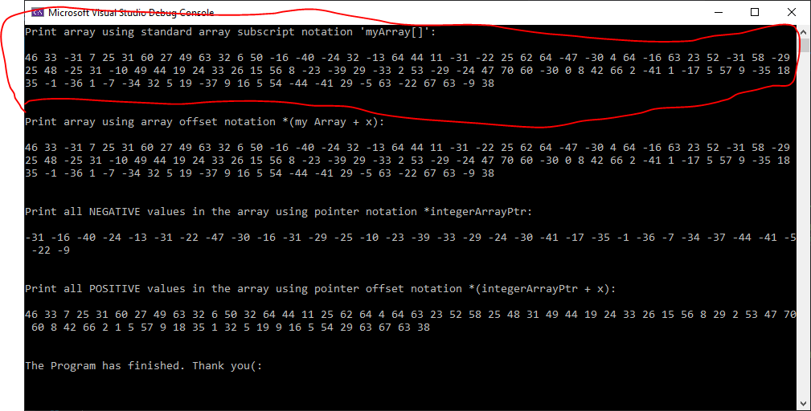

TEST 2

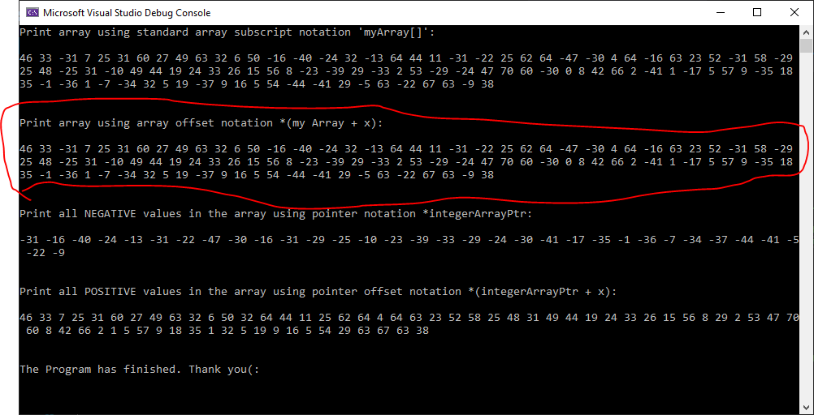

TEST 3

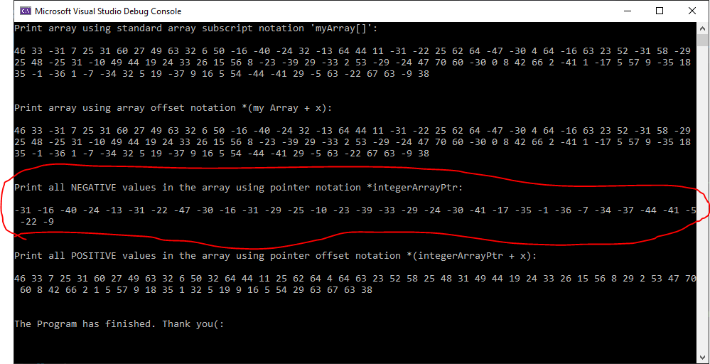

TEST 4

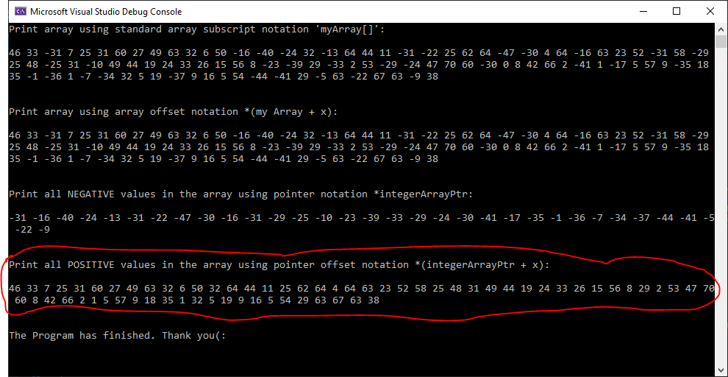

# Question 3

// LAB 2 - CIS 200

Question 3

***Notes:***

The **main function** can be defined with no **parameters** or with two **parameters** (for passing command-line **arguments** to a program when it begins executing). The two **parameters** are referred to here as argc and argv, though any names can be used because they are local to the **function** in which they are declared. ([www.itec.suny.edu](http://www.itec.suny.edu)).

Command line arguments in C/C++

Last Updated: 21-12-2018 (<https://www.geeksforgeeks.org/command-line-arguments-in-c-cpp/#:~:text=argv(ARGument%20Vector)%20is%20array,element%20is%20command%20%2Dline%20arguments>.)

The most important function of C/C++ is main() function. It is mostly defined with a return type of int and without parameters :

int main() { /* ... */ }

We can also give command-line arguments in C and C++. Command-line arguments are given after the name of the program in command-line shell of Operating Systems.  
To pass command line arguments, we typically define main() with two arguments : first argument is the number of command line arguments and second is list of command-line arguments.

int main(int argc, char *argv[]) { /* ... */ }

or

int main(int argc, char **argv) { /* ... */ }

* **argc (ARGument Count)** is int and stores number of command-line arguments passed by the user including the name of the program. So if we pass a value to a program, value of argc would be 2 (one for argument and one for program name)
* The value of argc should be non negative.
* **argv(ARGument Vector)** is array of character pointers listing all the arguments.
* If argc is greater than zero, the array elements from argv[0] to argv[argc-1] will contain pointers to strings.
* argv[0] is the name of the program , After that till argv[argc-1] every element is command -line arguments.
* argc: The number of arguments in the command line that invoked the program. The value of *argc* is nonnegative.
* argv: Pointer to an array of character strings that contain the arguments, one per string. The value argv[*argc*] is a null pointer.

## Source Code –see Q3_CIS-200-LAB2-DemetriusJohnson.cpp

## Screenshots

Test Table:

|  |  |  |  |  |  |  |
| --- | --- | --- | --- | --- | --- | --- |
| Test # | Valid / Invalid Data | Description of test | Input Value | Expected Output | Actual Output | Test Pass / Fail |
| 1 | valid | Run program and see if it displays number of arguments and the filename and path of user .EXE file for the program | NA | NA | See screenshot | pass |

TEST 1

